**Q5.** Use Collection Classes to store Integers. Create some methods for the following functionalities.  
    a. Include functions for pushing elements onto the stack.  
    b. Popping elements from the stack.  
    c. Checking if the stack is empty.

Input;

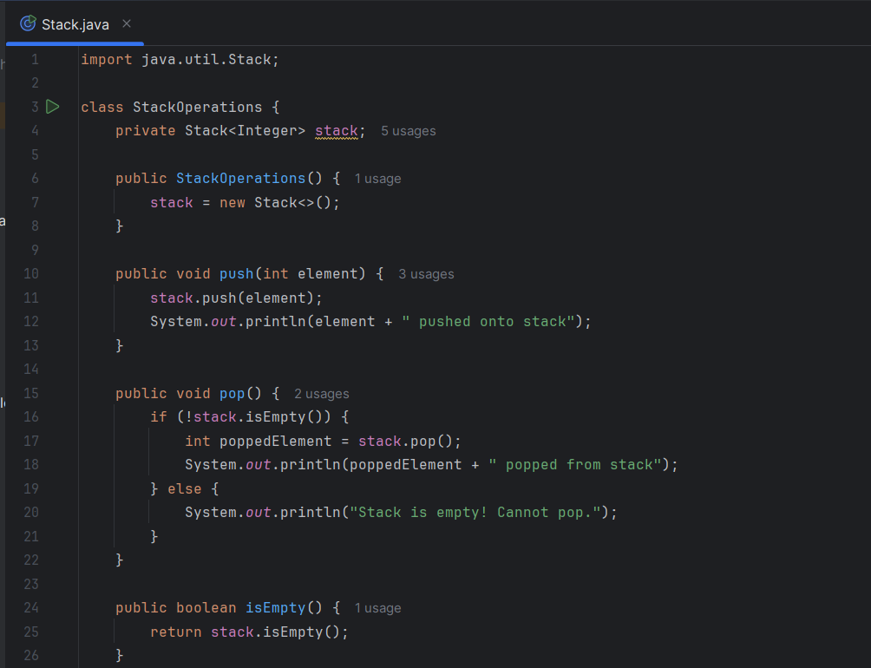

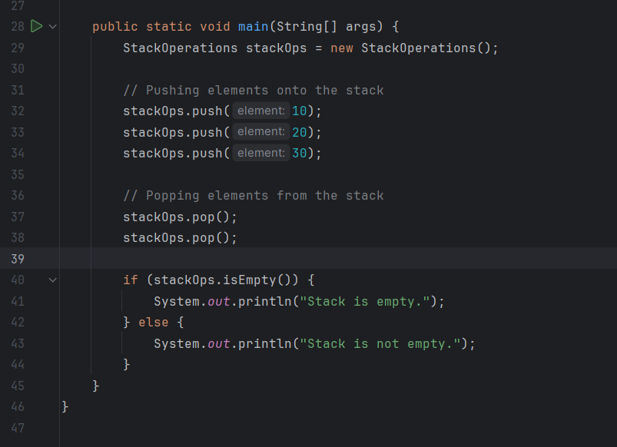

Output;

